RIVERSIDE DYER DINGHY ASSOCIATION

2022-2023 SAILING INSTRUCTIONS

RULES All races shall be governed by The Racing Rules of Sailing (RRS), the prescriptions of US Sailing, and the Riverside Dyer Dinghy Association (RDDA) Supplemental Sailing Instructions (attached hereto as Appendix B), and these Sailing Instructions. The current version of Development Rule DR22-01 Rule 18, the preamble to Section C, and Mark-Room shall apply. See Sailing Instruction Addendum 2022 Test Rule 18.

Audible-Signal Racing System as defined in Appendix U of the US Sailing Prescriptions shall apply.

SCHEDULE Refer to the Racing Schedule as posted on the Frostbiting/RDDA section of the RYC website riversideyc.org/frostbiting/frostbitingrdda for the dates and starting times for fleet racing and Special Events.

RACES As many races will be run each day as practical within a two hour time limit. Except for special events, no start shall take place later than 2 hours after the first scheduled warning signal (example – no start may occur later than 1600 for a 1400 scheduled first warning).

NOTICES TO COMPETITORS Supplemental instructions may be announced prior to any race by the Race Committee or posted by the Fleet Captains via email, or on the Riverside Yacht Club (RYC) RDDA website, or on the bulletin board at the head of the pier. Changes may include a change and/or extension of the Racing Schedule.

CHECKING IN Before her warning signal of her first race each day, each boat shall sail past the stern of the Race Committee Boat and hail her sail number until acknowledged by the Race Committee.

COURSES The course for each race may be announced orally from the Race Committee Boat. Course Descriptions are attached hereto as Appendix A. Other courses, not explicitly described in these Sailing Instructions, may be used as the Race Committee sees fit. Courses may be displayed on placards from the Race Committee Boat. Unless otherwise announced by the Race Committee, marks shall be passed on the same side as the starting mark on all courses except the "no gybe" course, and when a weather or leeward “gate” is announced as a mark of the course.

MARKS OF THE COURSE Marks shall consist of inflated buoys, government marks, or any other identifiable object selected by the Race Committee.

While racing, no boat may sail between any of the docks of the RYC marina.

The Race Committee may decide to set an “offset” mark near the weather mark and/or a weather and/or a leeward gate which shall consist of two marks approximately fifteen yards apart. If an offset mark is set and announced, boats must round the offset mark, after the weather mark, prior to continuing the course. If either a weather or a leeward gate is set and announced as a mark of the course, boats must sail between the two marks from the direction of the previous mark and subsequently round either mark prior to continuing the course. If the course is displayed on placards, a weather offset shall be designated by “+O”, a weather gate shall be designated by “+WG” and a leeward gate shall be designated with “+LG”.

STARTING AND FINISHING The Start Line shall be between a staff displaying a flag on the Race Committee Boat and a mark. The Finish Line (unless the course is shortened) shall be between a staff displaying a flag on the Race Committee Boat and a mark. Please note the Start and Finish Lines may be on the same side of the Race Committee Boat. After the start of each race, boats may re-cross the Start and Finish Lines.

STARTING The Starting Sequence shall be as described below. This modifies Appendix U.

Sound Signal | Meaning | RRS Event
Repeated horn | Announce Course | Warning
Two long | Two Minutes | Preparatory
One long, three short | One Minute, Thirty Seconds
One long | One Minute
Three short | Thirty Seconds
Two short | Twenty Seconds
One short | Ten Seconds
5 consecutive short One long | One for each of last 5 seconds Start | Start

INDIVIDUAL RECALL An Individual Recall will be signaled by one horn blast from the Race Committee. The Race Committee shall endeavor to hail each OCS boat. The Race Committee boat shall raise the X Flag and endeavor to relay each OCS boat by bow number on the radio to Chase Boats so they may attempt to alert any OCS boats failing to start properly. Failure by the Race Committee or chase boat to hail a boat that was OCS or failure of a competitor to hear the Individual Recall horn does not relieve the competitor of his or her responsibility to make a proper start. Any boat failing to return to start properly shall be recorded as “On Course Side” (OCS).

GENERAL RECALL A General Recall will be signaled by raising the 1st Repeater Flag and two short horns from the Race Committee Boat. A new Preparatory signal (two minutes before the start) will be given as soon as possible.

CANCELLATION The Race Committee may, after consultation with a Fleet Captain (or his designee), cancel racing for one or both divisions prior to the start of racing. Once racing has commenced on any given day, the Race Committee may abandon any race in progress or cancel racing for the day. (RRS 32)

SCORING A high point scoring system shall be used. Series and Season scoring will be on the basis of the percentage of points scored to possible points. Daily scoring by the Race Committee is unofficial.

Race Scoring
Define 'N' to be the number of boats that compete in a particular race. Each boat finishing that race and not thereafter retiring or being disqualified will be scored as follows:

Finishing Place Score
First N
Second Third Fourth
Each place thereafter
N-1
N-2
N-3
Subtract 1 point

All other boats that compete in that race, finish and thereafter are disqualified will be scored 0 point. Boats scored DNF and those that retire after finishing will receive 1 point. Boats that do not compete in that race (DNC) will not be scored.

Series & Season Scores
The Series score and the Season score for each boat will be a percentage calculated as follows: divide the sum of her race scores by the sum of the points she would have scored if she had placed first in every race in which she competed; multiply the result by 100. The qualified boat with the highest series score is the winner and others are ranked accordingly.

Ties and other rules
Race ties will be broken using rule A7. Series ties will be broken using rule A8.1. Rules A1, A3, A5, A6, A10 and A11 also apply.

CAPSIZE Any skipper who capsizes during the Ice Bowl Regatta or Winter Series and is not wearing a dry suit is finished racing for that day. Any skipper who capsizes during the Ice Bowl Regatta or Winter Series while wearing a dry suit has the option to return to racing or retire. Every skipper shall render all possible assistance to any person in peril when in a position to do so. Skippers rendering assistance shall be awarded at the skipper's option, either: (1) position at the time of his or her rendering assistance, if that can be determined by the Race Committee; (2) average for the day of all races, or (3) DNC. A capsize shall constitute damage for purposes of RRS 62. The RDDA strongly recommends that sailors wear a dry suit while sailing.

PROTESTS The protesting boat shall immediately inform the boat being protested by hailing the word "protest”. Immediately upon finishing, the protesting boat shall notify the Race Committee, giving the sail number(s) of the protesting and protested boat(s). This modifies RRS 61.1.

The protest will be heard immediately after racing using "Five Minute Justice”. The protestor and protested shall each select a judge from those present. Those two judges shall select a third judge. One of the judges shall be the timekeeper. Each of the parties and their witnesses shall have two minutes to make their statements. The judges shall make every effort to render their decision promptly. The judges will notify the RC of the results of the hearing. Spectators are encouraged to observe both the parties’ statements and the judges’ determination. This modifies RRS 91(a).

Exceptions: If one or both parties to the protest are not available immediately following racing, 5 Minute Justice shall be heard the following race day or at a mutually agreed time, organized by the protesting parties. If the judges decide there is boat damage, personal injury, gross misconduct, a redress against the Race Committee or other exceptional situation, a full hearing will be held as soon as possible, in accordance with RRS 63 and 91(a).
PENALTIES Except for "No Gybe" courses, the penalty for breaking a rule of Part 2 will be a “One Turn Penalty”. This modifies RRS 44.1. The penalty for violating Rule 42 shall also be a “One Turn Penalty”. Penalty turns MUST be taken as soon after the incident as possible and must include one tack immediately followed by one gybe (in either order.)

For "No Gybe" courses, the Scoring Penalty (RRS 44.3) will be used. RRS 44.3 is modified as follows: the Scoring Penalty will be 10%, and a boat taking a Scoring Penalty does not need to display a yellow flag.
Boats accepting the Scoring Penalty shall notify the Race Committee immediately upon finishing, or at the first reasonable opportunity.

If a protested person concedes a protest after a race and prior to a protest hearing, a 40% Scoring Penalty will be applied in accordance with RRS 44.3 (c)
PRIZES AND QUALIFICATION Prizes will be awarded at the end of the season. The number of awards will be at the discretion of the Fleet Captains. Division assignments will be made by the P&P Committee based on performance in the previous year or on prior experience.
To qualify for Series or Season prizes, a skipper must compete in at least one-half of the races sailed on a day, on at least one-half of the days actually sailed, excluding special events such as the Ice Bowl, Team Racing Regatta and the Single-Handed Championship. A skipper who capsizes or suffers a breakdown that forces him or her to retire for the day, prior to completing one-half of the races on any such day, will receive a qualification credit for that day.

To qualify for the Season, a skipper must fulfill the minimum requirement of 2 Service Days on Race Committee or Chase Boat duty to meet the Service Credit Requirement, at least 1 of which Service Days must be served during the Fall Series and the other during the Winter Series. To be clear, failure to serve at least 1 Service Day in each of the Fall and the Winter Series will result in the failure to qualify for the Season and the respective Series. Service days count as sailing qualification days, not to exceed 2 qualification days per Season. If racing is cancelled on the day service is to be performed, or the skipper is excused from service by the Race Committee PRO, a day of service credit is earned, but not a qualification day. If the skipper is excused from service on a day when racing occurs and the skippers chooses to then race and qualifies for that day, the skipper will earn a qualification day but not a day of service credit.

When Race Committee or Chase Boat duty is performed at a special event, the service counts towards the Season’s Service Credit Requirement, but does not count as a qualification day for a Series or the Season. Racing in a special event does not count as a qualification day for a Series or the Season.

PARTICIPANTS’ RESPONSIBILITIES As a condition precedent to his or her participation in any race or series (including without limitation all activities relating thereto) sponsored or undertaken by the Riverside Yacht Club, Inc. or the Riverside Dyer Dinghy Association, each participant agrees that the safety of the boat and its crew and the decision whether or not to start or continue a race is solely his or her responsibility, and each boat and each participant waives any and all claims, including without limitation any claim in respect of assistance given or not given, against Riverside Yacht Club, Inc. or the Riverside Dyer Dinghy Association, and their respective officers, directors, members, committees, employees, or agents, for any injury or damage resulting from such participation.

Each skipper must submit online a Waiver and Sign-Up form for the current season. Without such a valid Waiver on file with the RDDA, a skipper cannot participate.

APPENDIX A
RIVERSIDE DYER DINGHY ASSOCIATION

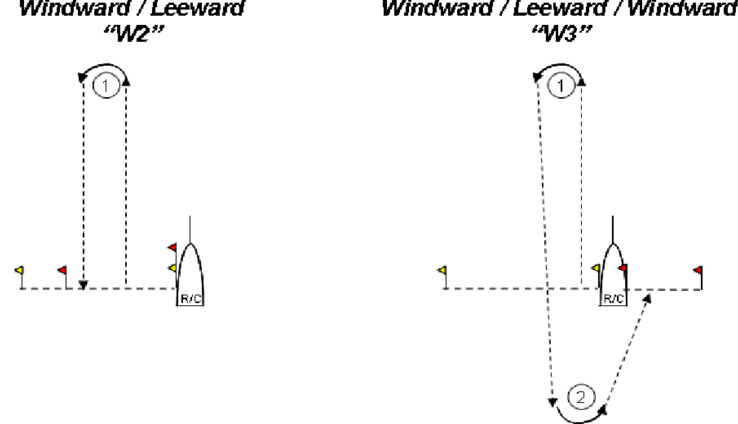
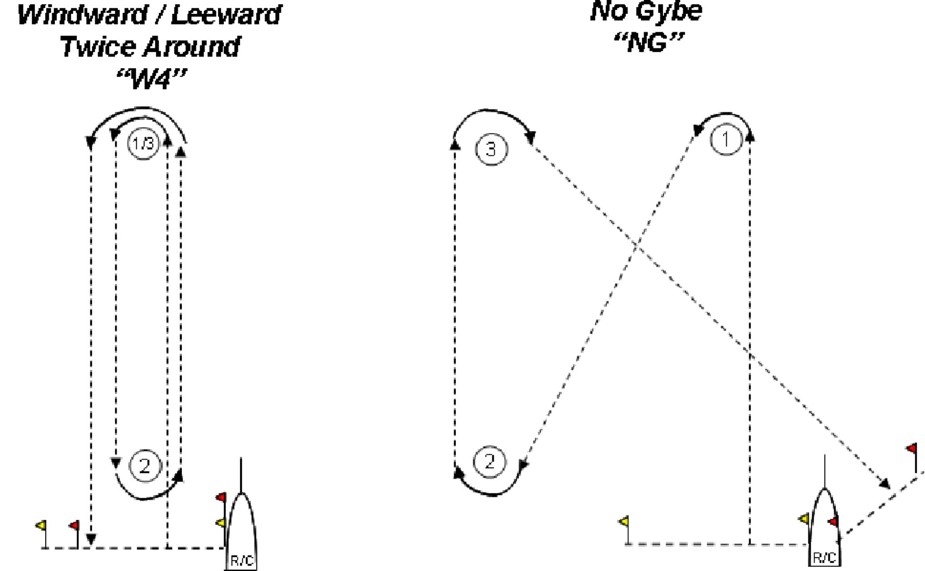

APPENDIX A - Continued RIVERSIDE DYER DINGHY ASSOCIATION
Courses

TRIANGLE MODIFIED GOLD CUP “T” “G”

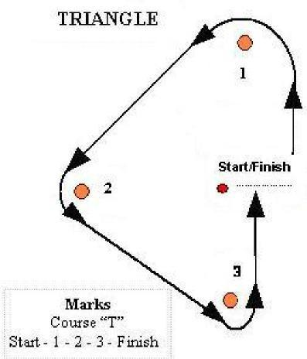
Note that the Finish Line shall be on the opposite side of the Race Committee Boat from the Start Line.

The modified Gold Cup course shall consist of 5 legs, starting from the Start Line to a windward mark, then to a reaching mark, then to a leeward mark, then to the windward mark, then to the Finish Line which shall be on the same side of the Race Committee Boat as the Start Line.

MODIFIED OLYMPIC “O”

The modified Olympic course shall consist of 6 legs, starting from the Start Line to a windward mark, then to a reaching mark, then to a leeward mark, then to the windward mark, then to the leeward mark, then to the Finish Line which shall be on the opposite side of the Race Committee Boat from the Start Line.

APPENDIX B
RIVERSIDE DYER DINGHY ASSOCIATION

POLICIES & PROCEDURES COMMITTEE
2020-2021- SUPPLEMENTAL SAILING INSTRUCTIONS

The purpose of the Policies & Procedures Committee is to ensure that the RDDA maintains strong one-design racing standards, and fair and competitive racing. The Supplemental Sailing Instructions may be changed during the season.
Personal Flotation U.S.C.G. Approved PFD's must be worn at all times while racing.
Flotation Sufficient to float boat and gear in a level position to permit bailing. The Fleet Captains and P&P Committee may spot check for adequate flotation that is properly secured and may limit racing for boats that do not meet the standards until they comply.

Weight Minimum required weight for boat and sailor is 385 lbs. If below this level, ballast must be added to a maximum of 80 lbs. A maximum of 40 lbs. of ballast which is capable of floating (plastic water/anti-freeze jugs) may be used, but must be securely fastened to the boat. All other required weight must be permanently attached to the boat. The boat flotation must be adequate to float the boat including any added ballast. It is the skipper’s responsibility to have his or her boat weighed and recorded. Boats with no recorded weight will be assigned a “Default Weight” of 165 lbs and skippers may subject to random weight checks. Members of the P&P Committee may weigh boats and skippers periodically.
Mast and Boom Aluminum Dyer DM1 and DM2 mast sections and 2" O.D. boom (.090 to .188 inch sections). Kenyon "A" mast sections and 2" O.D. booms purchased prior to November 1985. Masts may not rotate in the step nor be adjusted fore and aft or side to side while sailing.
Boom Length (A) Overall length between 8’6” and 8’7”, as measured from the back of the mast (when the boom is fitted in the sail track) to the end of the boom; and (B) the outhaul block “exit” must be between 8’4” and 8’5” when the block is in its normal position. The outhaul block must be fixed to the boom, i.e. not adjustable. The use of a clew tie down is optional, though recommended by the sailmaker.
Hull No alterations permitted including but not limited to adding stiffening and or requests made to Dyer for customized new build layouts and improvements
Centerboard & Slot Centerboards are available only through the fleet. The slot is to be at least 46” long and of constant width, which may not be less than 7/8”.
Rudder Rudders are available only through the fleet. Hiking sticks / tiller extensions may be added.
Sail Available only through the fleet. A new sail may only be purchased during a fleet purchase cycle which occurs every three to five fleet seasons. Sail purchase during the fleet cycle is not required, but if you do not buy a sail during the fleet cycle, you will have to wait until the next cycle in order to purchase a new sail. Exceptions are made for new boats and damage or loss of a sail. If you purchase a new sail as part of a fleet purchase, your “old” sail is not permitted to be used as an alternate full rig sail when racing. The 2017-2018 season was the first fleet season for the current sail.
Bow Numbers Bow Numbers consistent with the boat’s sail number must be in place unless an exemption is given by the Race Committee. Bow Numbers size shall be 9 inches tall. Bow Numbers shall be placed so that the top edge of each number is no more than 1” below the rail. The forward number on each side shall be no more than 2” from bow (as measured at the lowest point on the bow number). The separation between two bow numbers digits shall not exceed 1”.
Painter / Bow Line Approximately 15 feet long, 3/8 inch diameter and able to float.
Technology Sailors and boats are limited to a simple onboard compass and timer / watch and are restricted from utilizing navigational and performance aids such as GPS.
Rules and Penalties The P&P Committee and the RDDA believe that our racing must be self-regulating, and we encourage everyone to understand the rules and to take penalties appropriately, or to promptly protest.

- 9 -

